

**Important Dates**

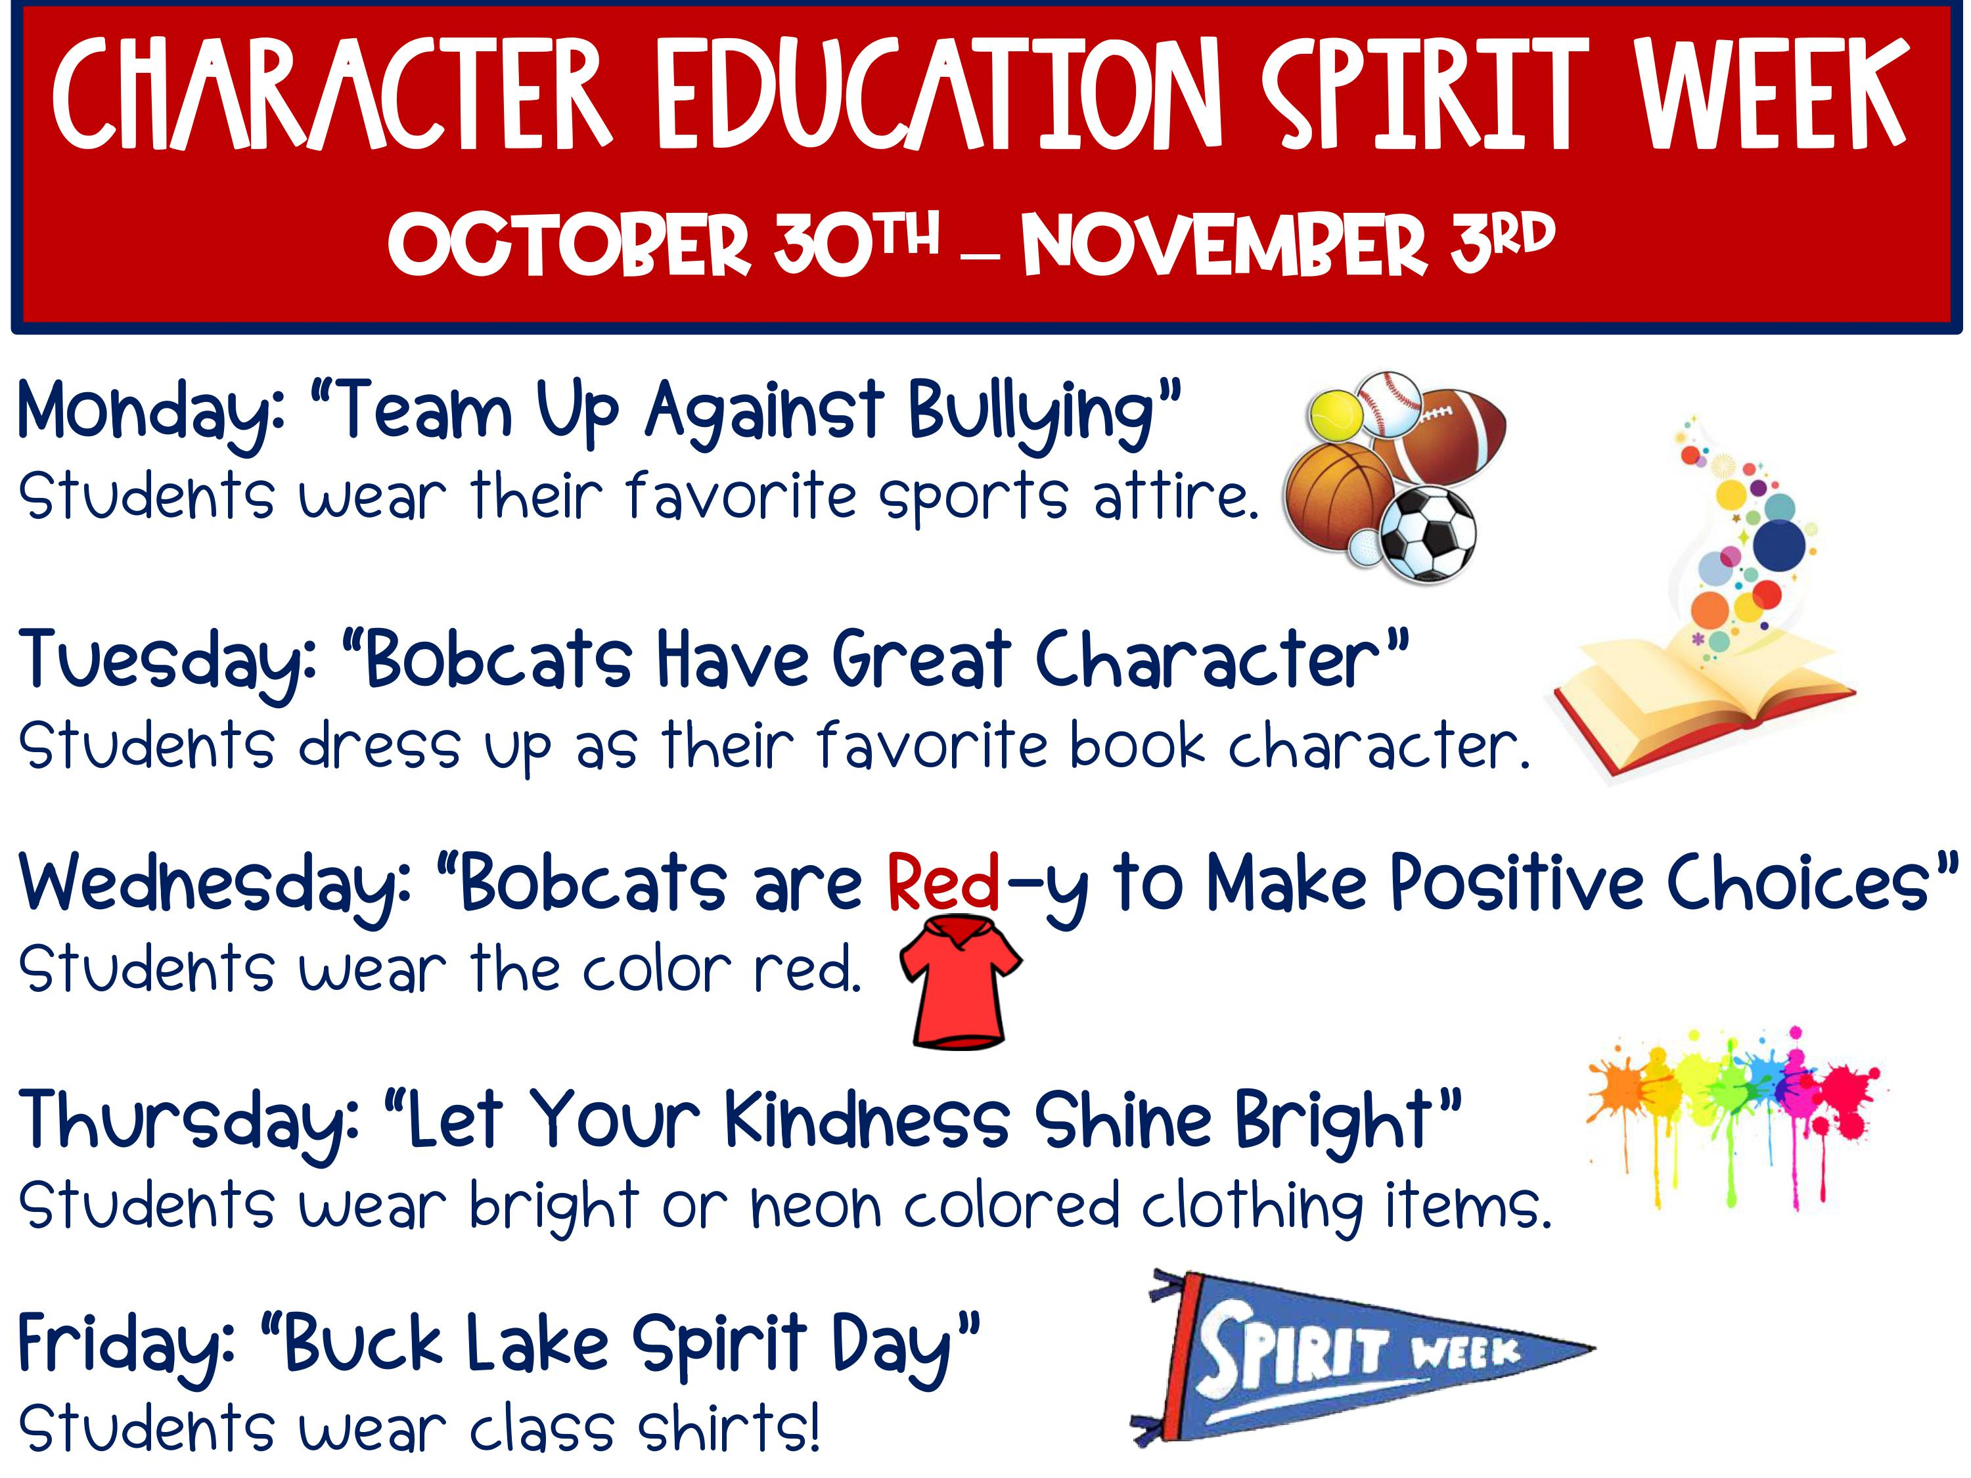

**13 Sage**

**24 James**



**Tuesday, 10/10**

* Field Trip to Aunt Louise’s Farm
* Health Screenings

**Friday 10/13** End of 9 Weeks

**Monday, 10/16**

**Teacher Planning Day (No School)**

**Wednesday, 10/18** Picture Retakes

**10/23-11/3**

Boosterthon Fun Run Collections

**Wednesday, 10/25**

50th Day of School (Dress in 50’s wear!)

**Tuesday, 10/31**

Fall Party and Favorite Book Character Dress Up Day

**Friday, 11/3** Fun Run!



**Savvas Reading-** **Unit 1 Week 3**

***Theme: What makes us want to visit a special place?***

***Letter Recognition & Sounds:***

Pp and Cc

***Sight Words:*** he, is, have, and

***Vocabulary:***

library, librarian, computer, movie

***Genre:*** Informational Texts

***Language and Conventions:***

Plural Nouns

**Math- Chapter 3:**

Compare Numbers Through 5

**The new Chapter 3 Test date is Wednesday, October 4th.**

**Science-** Autumn



Our trip to Aunt Louise’s Farm is quickly approaching. Please plan to send a lunch and drink with your child and have them wear their red class shirt and comfortable shoes!



**Sonja Darden’s Kindergarten Class**

**Buck Lake Elementary** 488-6133 [dardens@leonschools.net](mailto:dardens@leonschools.net)

**October 2, 2023**